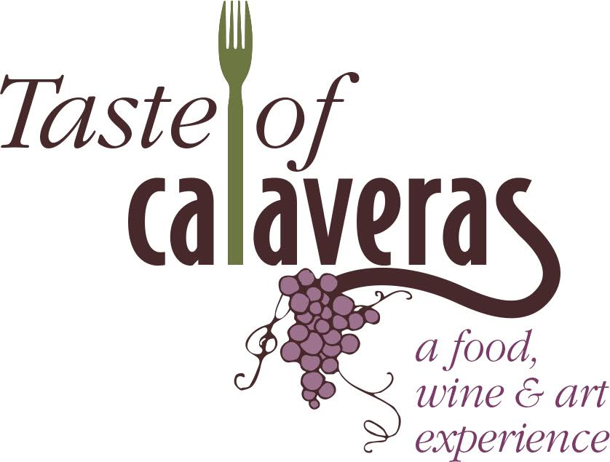

Saturday, April 27, 2019
12:00 – 4:00 PM
Ironstone Vineyards

Dear Artist and Crafter:
Angels Camp Business Association invites you to join in the 13th Annual Taste of Calaveras, a well-established and cherished celebration of wine, food, and art showcasing Calaveras County, the very best the region has to offer. We anticipate a large turnout for this thirteenth-year celebration!
Due to the high volume of interest and limited space available, art vendors will be selected by the Taste of Calaveras Committee. Please return the participation form along with a description of your art/items and photos for approval.
Taste of Calaveras 2019 will be held on Saturday, April 27th from noon to 4 p.m. at Ironstone Vineyards in Murphys. Please contact me if you have any questions, email tasteofcalaveras@gmail.com or call 209-736-1333.
Together let’s make this the best Taste of Calaveras ever!
Sincerely,
Jessica Johnston
Administrative Director
Angels Camp Business Association

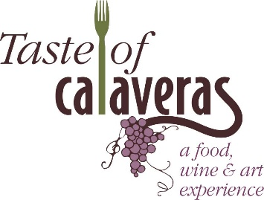
Saturday, April 27, 2019
12:00 – 4:00 pm
Ironstone Vineyards
Artist and Crafts Participation Form
Business Name: ____________________________________________________________________________________
Contact Name: _______________________________________ Phone: _______________________________________
Address: __________________________________________________________________________________________
City: ______________________________________ Zip Code: ______________________________________________
Email: ____________________________________________________________________________________________
Please submit photo of your handcrafted products and a short description of what you want to sell. Artwork and hand crafted items will be selected by our committee for participation in the event. Photos can be emailed to admin@angelscampbusiness.com or submitted with application to address below.

Vendor Fee: ______$20.00, this fee does NOT include a commemorative glass or plate for tasting.
_______$40.00, this fee includes one commemorative wine glass and one plate for tasting.
Please include check made payable to ACBA and mail to:
Angels Camp Business Association – PO Box 62 – Angels Camp, CA 95222.
Electricity Needed? ________________
You will be provided an 8 foot table to display and sell your handcrafted items. You need to provide your own table linens and any display items. If you need electricity, please write above, otherwise you will not be provided. The area that you will have your vendor space may/may not be in a covered but open air area (Garden Breezeway) – therefore you may need a tent. The lighting is not very good in the breezeway so you may want to bring lighting to showcase your items. Wi-Fi is not available. You are allowed to have two people at your table for your event to help set up and work at your table, any additional staff will need to purchase a Taste of Calaveras ticket. Set up time can begin after 10:00am.
Any questions please email Jessica Johnston at tasteofcalaveras@gmail.com or call 209-736-1333.
Jessica Johnston
Administrative Director
Angels Camp Business Association

