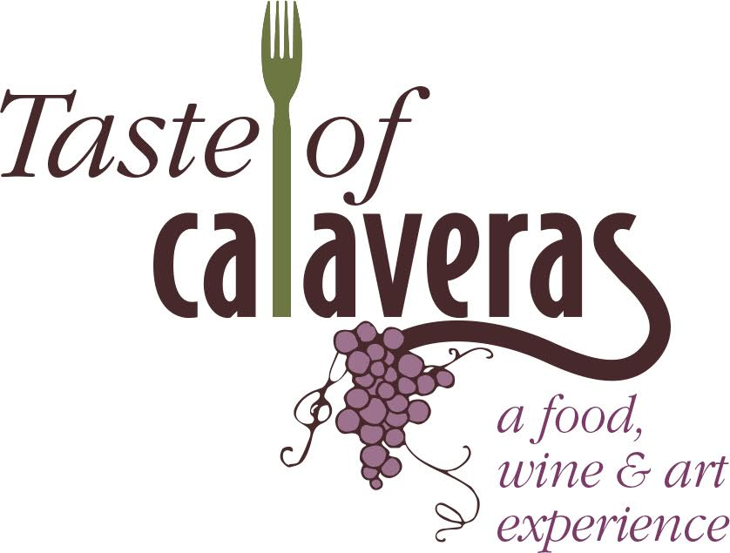

Saturday, April 27, 2019
12:00 – 4:00 PM
Ironstone Vineyards

Dear Restaurants and Wineries:
Angels Camp Business Association invites you to join in the 13th Annual Taste of Calaveras, a well-established and cherished celebration of wine, food, and art showcasing Calaveras County, the very best the region has to offer. Local artists will be on hand demonstrating their crafts as well as live local musicians. We anticipate a large turnout for this thirteenth-year celebration!
Restaurants and wineries will be promoted with an extensive print, radio and social media advertising promotion designed to draw guests from the Bay Area, Lodi, Stockton and Sacramento regions, as well as the Mother Lode. This year we will be featuring participating restaurants and wineries on our website, Facebook page, email blasts and media coverage so please let us know as soon as possible if you will be participating so that we have the opportunity to feature your business. In addition, we ask you to help us promote this event to your wine club members and restaurant customers.
Each restaurant and winery will be provided an 8-foot table that you can decorate to fit the image of your business. Bring wine club brochures and other marketing and promotional material. We are asking each restaurant to serve bite-size servings of a specialty menu item and each winery to pour their award-winning wines for the 300+ attendees. ACBA will provide the liquor license for wine tasting and proceeds benefit many community programs Angels Camp Business Association provides. Each guest will receive a commemorative etched wine glass.
We are planning educational demonstrations and talks for our guests as well, so if you’d like to be a speaker on a subject relating to food, wine or art, please let us know.
Taste of Calaveras will be held on Saturday, April 27th from noon to 4 p.m. at Ironstone Vineyards in Murphys. Please contact me if you have any questions, email tasteofcalaveras@gmail.com or call 209-736-1333.
Together let’s make this the best Taste of Calaveras ever!
Sincerely,
Jessica Johnston
Administrative Director
Angels Camp Business Association

Angels Camp Business Association
P.O. Box 62
Angels Camp, CA 95222
209-736-1333

Saturday, April 27, 2019 12:00 – 4:00 PM

Restaurant and Winery Participation Form

Restaurant/Winery Name:________________________________________________________
Contact Name:_________________________________ Phone: __________________________
Address:_______________________________________________________________________
City:_________________________________________ Zip Code:_________________________
Email:_________________________________________________________________________

Short description of food or wine to be served:
______________________________________________________________________________________________________________________________________________________________________________________________________________________________________________________________________________________________________________________________________________________________________________________________________
On-site Event Contact Name and Cell #______________________________________________
______________________________________________________________________________
Please return completed application to:
Angels Camp Business Association
PO BOX 62 Angels Camp, CA 95222

